Coaches,
Hopefully the start of school has gone well and that your season is off to a fantastic start. We are ecstatic to be able to host you for the 2022 Olathe Twilight!

Date: Saturday September 10th 2022

Times: 5:00pm Packet Pick up; NO coaches meeting
5:00pm Middle School Girls Race 3K unlimited entry
5:30pm Middle School Boys Race 3K unlimited entry
6:00pm C Team Girls Race 5k Unlimited entry
6:45pm C Team Boys Race 5k Unlimited entry
7:25pm JV Girls Race 5k Unlimited entry
8:00pm JV Boys Race 5k Unlimited entry
8:30pm Varsity Girls Race 5k 10 runner limit
9:00pm Varsity Boys Race 5k 10 runner limit
9:30pm Awards Ceremony

Medals: Top 20 in HS races & Top 15 in MS races will earn medals. Top two teams in HS varsity race will receive trophies.

Location: Olathe District Activities Complex (20925 159th St, Olathe, KS 66062). The boy’s and girl’s course will both be 5000 meters. Middle School races are will both be 300 meters.

Invited Teams: Blue Springs South, Blue Valley North, Blue Valley Northwest, Blue Valley Southwest, Blue Valley West, DeSoto, KC Washington, Gardner-Edgerton, Great Bend, JC Harmon, Liberty North, Liberty High, Maize South, Mill Valley, Olathe East, Olathe North, Olathe Northwest, Olathe South, Olathe West, Omaha South, Park Hill, Pleasant Ridge, Rockhurst, Shawnee Mission East, Shawnee Mission North, Shawnee Mission Northwest, Shawnee Mission South, Shawnee Mission West, St. Thomas Aquinas, St. James, St. Teresa, Trinity Academy, Turner, Washburn Rural, William Chrisman.

Entry Fee: $150 per team, this includes boys and girls team. Please mail fee to the address at the header of this letter or bring it to the meet at packet pick up. Individual entries are $10.00 per runner. Middle School races will be free again this year.

Entries: Entries will be done on ks.milesplit.com. The registration site is currently open and will remain open until Wednesday Sep 7th at 10pm. Please enter every athlete that has the possibility of running. No need to designate which race you plan to have athlete run in. The most important thing is that they are in the system. If you have any issues please see Milesplit’s FAQ Page; https://support.milesplit.com/en/t/meet-registration
Link for registration -> https://ks.milesplit.com/meets/497514-olathe-twilight-2022#.YwZiMXbMLIU

Restrooms: There are restrooms underneath the grandstands that will be open.

Heat/Weather: It is out hope that by running later in the evening any heat may have subsided. However, if the heat becomes extreme (or appears that it may) we will notify you of any changes as soon as possible. PLEASE do not race any athletes that are not prepared for competition. Regarding lightning: Please include a contact # in your email so that I can reach you if there will be lighting the evening of the meet. We will do everything in our power to run the meet that evening but not at the risk of anyone’s health.
Results/Timing: We will be using chip timing again this year so we can give you complete results as quickly as possible. Make sure you attach the chip securely to the athletes shoe and that we receive ALL chips back prior to you leaving the meet. There is a $20 per chip fee for unreturned timing chips.

We will NOT be timing the Middle School races. There will be a large finish line clock at the finish line so that the middle school athletes/coaches/parents can view their finish time as they cross the finish line.

Starting Line/Finish Area: We ask that all parents and fans stay clear of the finish area and do not attempt to contact any athlete still in the finish chute. Keeping the finish area clear will help us conduct a smooth exit from the finish and ensure accurate race results.

The Course: The course will be run around the Olathe District Activities Complex. The course will be run on the grass around the perimeter of ODAC with the finish on the track inside the Track/Football Stadium. There are a few short sections where the route crosses the parking lot. At these sections there will be sections of turf or rubber mats so that runners are not running on concrete. New this year, the finish line for the middle school races will also be on the track.

Team Camps: We are asking that you set up your team camps inside the Soccer Field and/or Soccer Stadium. There is grass on the outside of the field (still within the fence) that can accommodate everyone. Please do not set up on the turf.

Parking: There will be a charge for parking just like in years past. $5 per vehicle entering ODAC. (If your athletes drive themselves they will also need to pay $5 per car).

We will be using an online ticketing system where you can buy your pass or you can pay using exact cash. NO CHANGE WILL BE GIVEN. The online ticketing system instruction are on a separate attachment. Cost for online tickets is $5 plus a service charge.

Within ODAC there will be two sections that are blocked off for safety reasons but there should be more than enough parking in the normal parking areas.

T-Shirts: T-shirts will be on sale while supplies last for $20.

Concessions: We will have food trucks until they sell out. We hope your families can enjoy themselves and stay for the evening with great atmosphere and food!

Please don’t hesitate to contact me with any questions or concerns. My phone number is (913) 909-7546 and my email is lhusemanon@olatheschools.org. We are excited that you and your team will be joining us. We thank you in advance for making this such a great cross country experience for so many kids. I wish you and your team the very best of luck this season and thank you for starting it off with us. See you September 10th.
Sincerely,

Levi Huseman
Olathe North Cross Country
Olathe Twilight Middle School Race Information

Date: Saturday September 10th 2022

Times: 5:00pm Middle School Girls Race 3K unlimited entry
5:30pm Middle School Boys Race 3K unlimited entry
6:00pm High School Races Begin

Location: Olathe District Activities Complex (20925 159th St, Olathe, KS 66062). Middle School races will both be 3000 meters.

Invited Teams: Any and All Middle Schools in the area are invited to attend.

Entry Fee: Middle School races will be free again this year.

Medals: Top 15 in both MS races will receive medals. The medals will be given to the kids in the chute as they finish.

Entries/Results/Timing: We will NOT be timing the Middle School races. There will be a large finish line clock at the finish line so that the middle school athletes/coaches/parents can view their finish time . Therefore NO entries need to be sent in beforehand for middle school athletes..

Parking: There will be a charge for parking just like in years past. $5 per vehicle entering ODAC. (If your athletes drive themselves they will also need to pay $5 per car).
We will be using an online ticketing system where you can buy your pass or you can pay using exact cash. NO CHANGE WILL BE GIVEN. The online ticketing system instruction are on a separate attachment
Within ODAC there will be two sections that are blocked off for safety reasons but there should be more than enough parking in the normal parking areas.

Restrooms: There are restrooms underneath the grandstands that will be open.

Team Camps: We are asking that you set up your team camps inside the Soccer stadium. There is grass on the outside of the field (still within the fence) that can accommodate everyone. Please do not set up on the turf.

Starting Line/Finish Area: We ask that all parents and fans stay clear of the finish area and do not attempt to contact any athlete still in the finish chute. Keeping the finish area clear will help us conduct a smooth exit from the finish and ensure accurate race results.

The Course: The course will be run around the Olathe District Activities Complex. The course will be run on the grass around the perimeter of ODAC with the finish line adjacent to the start line for middle school races.

T-Shirts: There will be T-Shirts being sold for $20 by the Olathe North Cross Country Booster Club

Concessions: The Olathe North Booster Club will be selling concession underneath the Football/Track Grandstand.
Olathe District Activities Complex

The 5000m course is a large loop that the athletes will run 1.5 times

1st Mile

2nd Mile

3rd Mile and Finish

5K Course Map
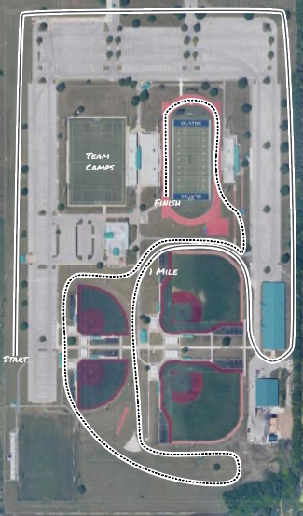
Olathe District Activities Complex

The 3000m course is a large loop that the athletes will run once.

1st Mile

2nd Mile

3K Course Map
Bus Parking
Due to the size of the meet and need for additional car parking we are forced to move buses from the previous parking area on the east side of the Track Complex, buses will need to drop off athletes on the north end of the soccer field. And then depart ODAC to park at Indian Trail Middle School (1440 E 151st St, Olathe, KS 66062) for the duration of the meet. Once you are ready to leave you would then need to call your bus so they may return to pick up athletes.

Bus Drop Off – Follow Arrows, and Please drop off at the Star.
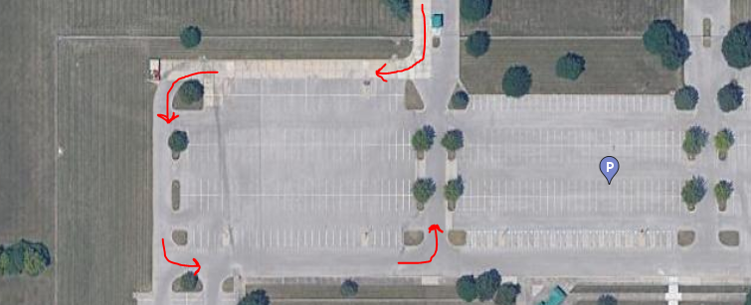

Parking at Indian Trail Middle School – Park in the outlined areas. Please DO NOT park buses at Olathe South as they have a volleyball event.